XK-VOICE-SQ66
External PDM Microphone Array
Soldering, Wiring, Firmware Selection and Windows Test Guide
For the XMOS XVF3800 XK-VOICE-SQ66 Development Kit
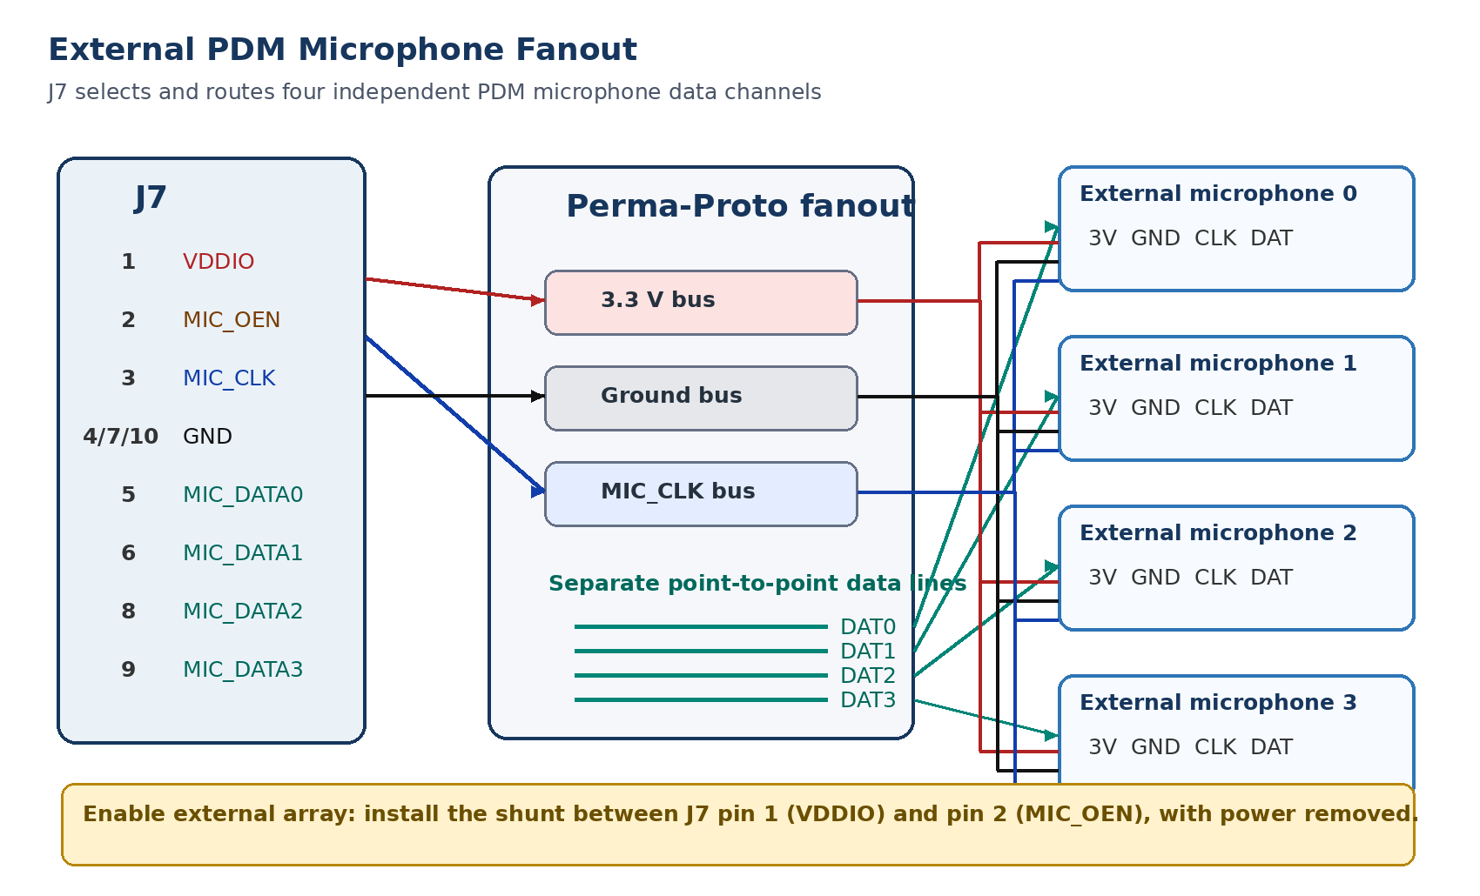
Revision 0.1 | 20 July 2026

1. Purpose and Key Conclusion
This guide provides a controlled procedure for soldering the external microphone connector, constructing a four-microphone PDM fanout, selecting the external array, verifying every microphone channel, selecting the correct stock firmware geometry, and testing beamforming and ASR-oriented outputs on Windows.
Key conclusion
The external microphones are not discovered or enumerated by software. The MIC_OEN hardware line selects the external microphone path. The XVF3800 firmware still expects four PDM channels and interprets them using the microphone geometry compiled into the firmware. A matching stock square or linear array can use the corresponding prebuilt firmware. A different geometry or channel ordering requires a custom firmware build.

1.1 Assumptions and limitations
- J7 pinout: The user-supplied schematic extract reproduced in this guide is treated as the authoritative connector pin map.
- External enable polarity: This guide follows the provided hardware plan that MIC_OEN is enabled by pulling it high to VDDIO with a shunt between J7 pins 1 and 2.
- Active channels: Four microphones are used at one time. The remaining two Adafruit microphones are spares or swap-in test units.
- Host mode: Initial testing is performed in XVF3800 USB Accessory (UA) mode on Windows.
- Custom geometry path: The uploaded guides state that arbitrary geometries are configured in source files, but do not identify one universal geometry-file path. The source-release search procedure in Section 10 avoids guessing.
- PDM edge selection: All four Adafruit microphone SEL jumpers should initially remain in the same factory-default state. The XMOS documents do not specify the required edge selection in the supplied excerpts; change SEL only if channel validation demonstrates an edge-related problem.

1.2 Safety and damage-prevention rules
Power rule
Disconnect the SQ66 USB cable, XTAG4 cable and any Raspberry Pi power before soldering, changing the MIC_OEN shunt, connecting or disconnecting microphones, or moving data wires. Do not hot-plug the external PDM array.

- Use an ESD-safe work surface and avoid touching microphone ports or exposed IC pins.
- Do not apply 5 V to J7. VDDIO is the board I/O supply and is nominally 3.3 V.
- Never tie MIC_DATA0, MIC_DATA1, MIC_DATA2 or MIC_DATA3 together.
- Before power is applied, verify that VDDIO is not shorted to any ground pin.
- Identify connector pin 1 from the PCB square pad or silkscreen. Do not infer board orientation solely from the schematic drawing.

2. Equipment and Materials
Item | Purpose / note
XK-VOICE-SQ66 development kit | XVF3800 evaluation board.
XTAG4 and ribbon cable | Firmware load, RAM execution and debug connection.
2 x 5 TSW-105 header | Soldered into J7 external microphone footprint.
4 x Adafruit 4346 PDM JST microphones | Active test array. Two additional units remain as spares.
4 x Adafruit 4209 JST-to-male-header cables | Connect each microphone to the fanout board.
Adafruit 1214 Perma-Proto board | Power, ground and clock fanout plus four separate data routes.
TSW-102 2-pin header + SNT-100 shunt | Used to connect J7 VDDIO to MIC_OEN.
Fine-tip temperature-controlled soldering iron | Header and fanout soldering.
Flux, solder wick and electronics solder | Reliable joints and bridge removal.
Digital multimeter with continuity mode | Mandatory pre-power verification.
Magnification and good lighting | Inspection for bridges, cold joints and lifted pads.
Optional oscilloscope / logic analyzer | Verify 3.072 MHz MIC_CLK and PDM activity.
Recommended: four 1 x 4 female socket headers | Allows the male-header ends of the Adafruit cables to be removable. Without these, solder the male pins directly to the Perma-Proto.
Recommended: 2 x 5 female harness or individual female leads | Connects the J7 male header to the Perma-Proto without soldering permanent wires to the SQ66 board.

3. J7 External Microphone Connector
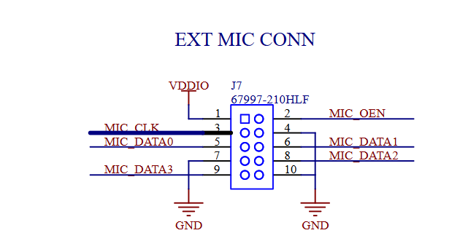
Figure 1. User-supplied J7 external microphone connector schematic. The square pad denotes pin 1 in the schematic symbol.
J7 pin | Signal | Direction / role | External-array connection
1 | VDDIO | 3.3 V I/O supply | Connect to the fanout 3.3 V bus and to one side of the MIC_OEN jumper.
2 | MIC_OEN | External microphone output-enable control | Connect only to the second side of the 2-pin jumper. Install shunt to pull high for external microphones.
3 | MIC_CLK | Clock output from XVF3800 | Connect to CLK on all four active PDM microphones. Nominal clock is 3.072 MHz.
4 | GND | Ground | Connect to fanout ground bus.
5 | MIC_DATA0 | PDM input channel 0 | Connect only to DAT on external microphone 0.
6 | MIC_DATA1 | PDM input channel 1 | Connect only to DAT on external microphone 1.
7 | GND | Ground | Connect to fanout ground bus; may be used as an additional ground return.
8 | MIC_DATA2 | PDM input channel 2 | Connect only to DAT on external microphone 2.
9 | MIC_DATA3 | PDM input channel 3 | Connect only to DAT on external microphone 3.
10 | GND | Ground | Connect to fanout ground bus; may be used as an additional ground return.

Important
J7 data-line numbers define the firmware logical microphone indices: DAT0 becomes MIC0, DAT1 becomes MIC1, DAT2 becomes MIC2 and DAT3 becomes MIC3. Record the physical position of each microphone against that logical index before beamforming tests.

4. Fanout Board Wiring

Figure 2. Recommended fanout arrangement. Shared 3.3 V, ground and clock; four independent data lines; MIC_OEN shunt between pins 1 and 2.

4.1 Electrical connection matrix
External mic terminal | Microphone 0 | Microphone 1 | Microphone 2 | Microphone 3
3V | J7 pin 1 VDDIO | J7 pin 1 VDDIO | J7 pin 1 VDDIO | J7 pin 1 VDDIO
GND | J7 pins 4/7/10 ground bus | Same ground bus | Same ground bus | Same ground bus
CLK | J7 pin 3 MIC_CLK | Same clock bus | Same clock bus | Same clock bus
DAT | J7 pin 5 MIC_DATA0 | J7 pin 6 MIC_DATA1 | J7 pin 8 MIC_DATA2 | J7 pin 9 MIC_DATA3

The Adafruit microphone breakout exposes 3V, GND, CLK and DAT on its JST connector. Its product specification lists a 1 to 3.25 MHz clock range, which includes the XVF3800 nominal 3.072 MHz microphone clock. The breakout also provides a left/right edge-selection solder jumper; keep all active microphones configured identically during initial bring-up. [4]

4.2 Recommended Perma-Proto layout
1. Reserve one long row for 3.3 V. Connect J7 pin 1 to this bus and route it to the 3V terminal of all four microphone connectors.
2. Reserve one long row for ground. Connect at least one J7 ground pin to the bus; using more than one J7 ground connection is acceptable and can improve return-path quality.
3. Reserve one short, direct row for MIC_CLK. Connect J7 pin 3 and branch to all four microphone CLK terminals. Keep this bus compact and avoid a long loop around the board.
4. Create four separate DAT routes. Route each microphone DAT terminal point-to-point to its corresponding J7 data pin. Do not share a data row.
5. Install the MIC_OEN jumper. Mount the 2-pin header so one pin connects to J7 pin 1 and the other to J7 pin 2. Label it EXT MIC ENABLE.
6. Provide removable microphone sockets when possible. Install one 1 x 4 female header for each Adafruit cable. When using only the parts already purchased, solder the male-header cable end into the Perma-Proto holes and provide strain relief.
Signal-integrity practice
Keep MIC_CLK and DAT wiring short, route ground nearby, avoid loose jumpers, and secure cables against movement.

5. Soldering Procedure

5.1 Solder the 2 x 5 J7 header onto the SQ66
1. Remove all power and cables from the SQ66 board.
2. Locate J7 and identify pin 1 from the square pad or board marking. Compare the footprint against Figure 1 before inserting the header.
3. Insert the TSW-105 header from the intended mating side. Hold it perpendicular to the PCB.
4. Tack-solder one corner pin using a small amount of solder.
5. Reheat the tack while gently aligning the header so it is square and fully seated.
6. Tack the diagonally opposite corner and re-check alignment.
7. Solder the remaining eight pins. Heat the pad and pin together; feed only enough solder to form a smooth concave fillet.
8. Inspect both rows under magnification. Remove any bridge with flux and solder wick.
9. Use continuity mode to confirm each header pin connects to its pad and no adjacent pins are shorted.

5.2 Assemble the Perma-Proto fanout
1. Mark the board before soldering: 3V3, GND, CLK, DAT0, DAT1, DAT2, DAT3 and EXT ENABLE.
2. Install female microphone sockets or position the four Adafruit cable ends. Orient all four connectors identically so pin-reading errors are visible.
3. Install the J7 harness connection points and the two-pin MIC_OEN header.
4. Solder the 3.3 V bus, ground bus and compact clock bus.
5. Solder each DAT line independently. Use different labels or heat-shrink identifiers rather than relying only on wire color.
6. Add mechanical strain relief to cable entry points. The solder joints should not carry cable tension.
7. Clean flux residue as appropriate for the solder/flux used and inspect every joint.

6. Pre-Power Verification and Staged Bring-Up
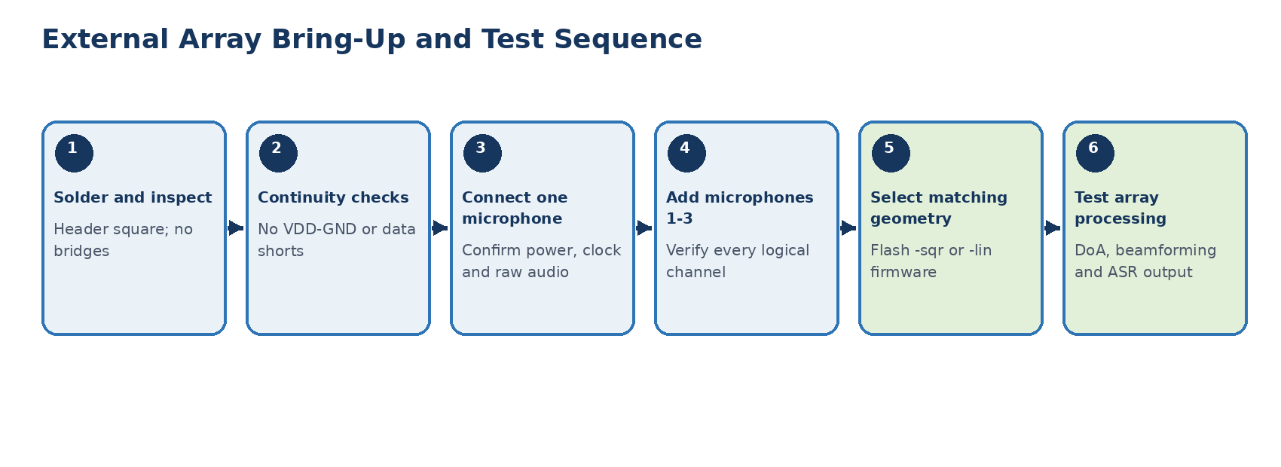
Figure 3. Staged bring-up sequence. Do not connect all four microphones before one channel has been proven.

6.1 Mandatory continuity checks
☐ J7 pin 1 VDDIO is not shorted to J7 pins 4, 7 or 10 GND.
☐ J7 pins 4, 7 and 10 are mutually continuous through the fanout ground bus.
☐ J7 pin 3 reaches CLK on all four microphone connectors and no DAT terminal.
☐ J7 pin 5 reaches only microphone 0 DAT.
☐ J7 pin 6 reaches only microphone 1 DAT.
☐ J7 pin 8 reaches only microphone 2 DAT.
☐ J7 pin 9 reaches only microphone 3 DAT.
☐ No two MIC_DATA lines are shorted together.
☐ With the shunt removed, J7 pins 1 and 2 are open. With the shunt installed, they are continuous.
☐ Every Adafruit cable pin is mapped to the correct 3V, GND, CLK or DAT terminal; verify by continuity rather than assumed color.

6.2 First powered test: one microphone only
1. Remove the MIC_OEN shunt and connect only microphone 0 to the fanout.
2. Connect the fanout to J7 while the SQ66 remains unpowered.
3. Install the MIC_OEN shunt between J7 pins 1 and 2.
4. Power the SQ66 through USB. Measure approximately 3.3 V between VDDIO and GND before proceeding.
5. When an oscilloscope or logic analyzer is available, verify a nominal 3.072 MHz clock at the microphone CLK terminal and activity on DAT while speaking.
6. Route MIC0 raw audio to the Windows host using Section 8. Confirm clean, intelligible audio before adding the next microphone.
7. Power down, add one microphone, and repeat until all four channels are active.
Stop condition
Immediately remove power if VDDIO collapses, the board resets repeatedly, a component becomes hot, or the current draw changes sharply when a microphone is added.

7. Physical Array Geometry and Channel Assignment
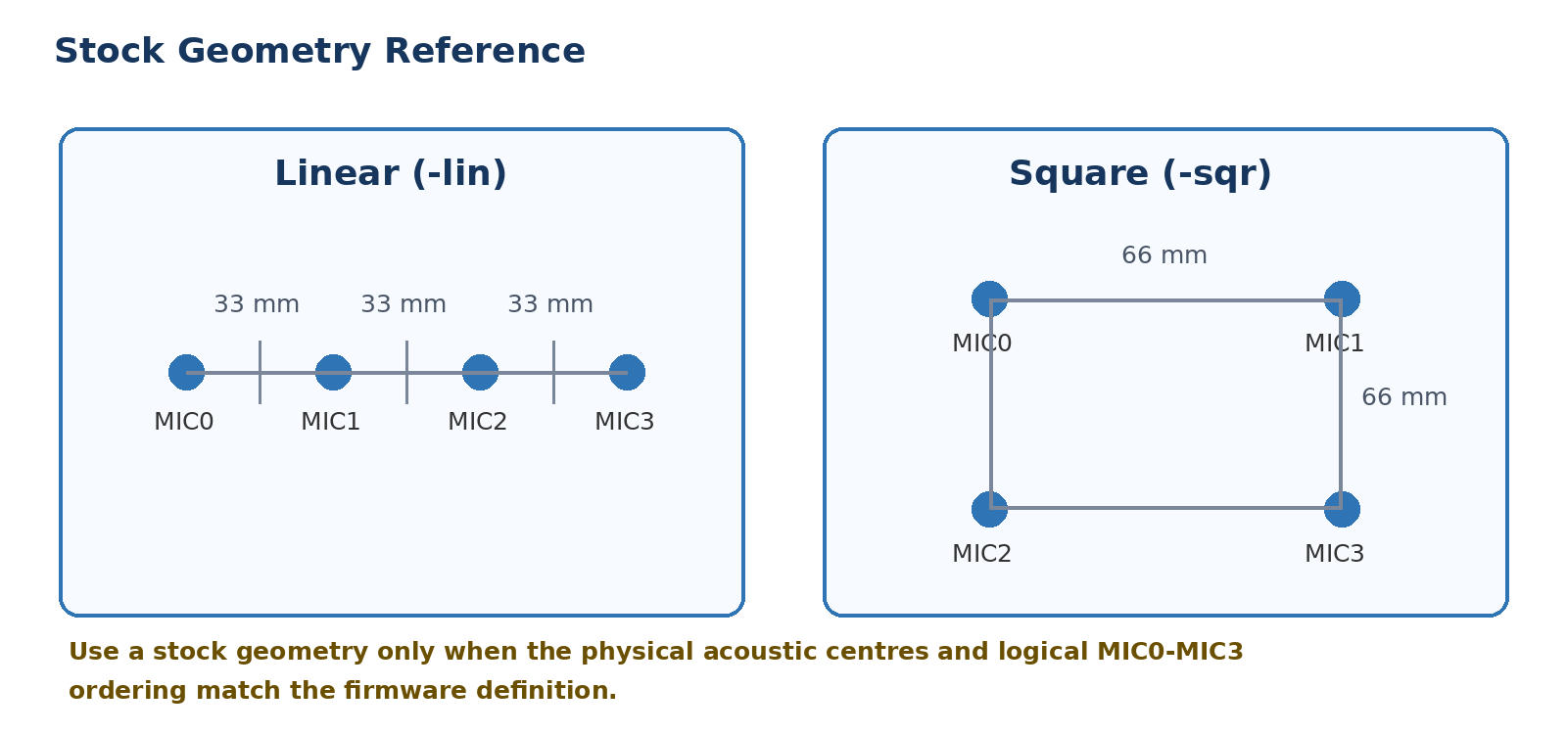
Figure 4. Stock XVF3800 geometry targets. Drawings are logical references, not SQ66 onboard physical-microphone labels.
The standard XVF3800 builds support a four-microphone linear array with 33 mm spacing or a square/rectangular configuration represented by the SQ66 66 mm square. The firmware geometry is selected at build time and cannot be changed while the device is running. The datasheet states that spacings up to 100 mm are possible but are uncharacterized. [1][2]
- Use stock square firmware when: the four acoustic centres form the intended square/rectangle, the physical positions match the logical MIC0-MIC3 coordinates, and the array orientation is documented.
- Use stock linear firmware when: the four microphones are collinear at 33 mm spacing and logical ordering follows the firmware coordinate order.
- Build custom geometry when: spacing, shape, height, logical order, or array orientation differs from the standard configuration.
- Mounting requirement: keep the acoustic port of every microphone unobstructed and give each microphone a comparable, independent acoustic path. Do not place one microphone behind thicker foam or a longer channel than the others.
- Measurement reference: measure the microphone acoustic centre, not the edge of the breakout PCB or connector.
Logical input | J7 signal | Physical position | Measured X (m) | Measured Y (m) | Measured Z (m)
MIC0 | MIC_DATA0 / pin 5
MIC1 | MIC_DATA1 / pin 6
MIC2 | MIC_DATA2 / pin 8
MIC3 | MIC_DATA3 / pin 9

8. Select the External Array and Verify It on Windows

8.1 Hardware selection
1. Power off the SQ66 and Windows USB connection.
2. Connect the completed fanout and four microphones.
3. Install the shunt between J7 pin 1 VDDIO and J7 pin 2 MIC_OEN.
4. Reapply USB power. The external array is selected electrically; Windows will not show a new microphone device or four separate USB microphones.
No automatic recognition
The board does not identify the external microphone model, spacing or position. The same four logical inputs remain present. The firmware geometry must be selected separately.

8.2 Flash the matching stock USB firmware
For first tests, retain USB Accessory mode. Select the 48 kHz square or linear image from the XVF3800 binary release package. Replace the example path with the actual file location.
Square external array example
xflash -l
xflash .\binaries\usb\48kHz\application_xvf3800_ua-io48-sqr.xe

Linear external array example
xflash .\binaries\usb\48kHz\application_xvf3800_ua-io48-lin.xe

A square build does not convert a physically linear array into a square array, and vice versa. The suffix determines the compiled microphone model and the SQ66 topology control state. [2]

8.3 Verify control and compiled geometry
Run from the Windows host-tool directory
.\xvf_host.exe --use usb VERSION
.\xvf_host.exe --use usb AEC_NUM_MICS
.\xvf_host.exe --use usb AEC_MIC_ARRAY_TYPE
.\xvf_host.exe --use usb AEC_MIC_ARRAY_GEO
.\xvf_host.exe --use usb --dump-params > external_array_baseline.txt

Command | Expected interpretation
VERSION | For release 3.2.1, the guide example returns 3 2 1.
AEC_NUM_MICS | Should report four microphone inputs.
AEC_MIC_ARRAY_TYPE | 1 indicates linear; 2 indicates square/circular.
AEC_MIC_ARRAY_GEO | Returns 12 floating-point values: X, Y and Z coordinates for MIC0 through MIC3, in metres.
--dump-params | Creates a baseline record before test routing or tuning changes.

8.4 Configure Audacity
- Set playback and recording device to XMOS XVF3800 Voice Processor.
- Set the project sample rate to the firmware interface rate, normally 48 kHz for an -io48 image.
- Record two channels.
- Disable Windows enhancements or automatic level processing on the host when repeatable measurements are required.
- Label each recording with firmware, geometry, microphone set, distance, angle and room condition.

8.5 Verify raw channels in pairs
The raw microphone signals are internally decimated to 16 kHz. On a 48 kHz USB bus, enable output upsampling before routing the raw channels. Then test microphones 0/1 and 2/3 as stereo pairs. [2]
Route raw MIC0 to left and raw MIC1 to right
.\xvf_host.exe --use usb AUDIO_MGR_OP_UPSAMPLE 1 1
.\xvf_host.exe --use usb AUDIO_MGR_OP_L 1 0
.\xvf_host.exe --use usb AUDIO_MGR_OP_R 1 1

Route raw MIC2 to left and raw MIC3 to right
.\xvf_host.exe --use usb AUDIO_MGR_OP_L 1 2
.\xvf_host.exe --use usb AUDIO_MGR_OP_R 1 3

1. Start a recording in Audacity.
2. Tap or click near one microphone at a time without touching the microphone port.
3. Confirm the energy appears in the expected left/right channel and document the physical microphone identity.
4. Speak at a fixed distance and listen for hiss, periodic tones, clipping, missing samples, alternating valid/invalid audio or large level mismatch.
5. Repeat after swapping a spare microphone into any questionable channel. This separates microphone failure from fanout or SQ66 input failure.
Pass criterion
All four logical channels are present, correctly mapped, clear and stable. Do not evaluate beamforming or DoA until this criterion is met.

8.6 Restore a processed output
Common processed-left / silence-right routing
.\xvf_host.exe --use usb AUDIO_MGR_OP_L 8 0
.\xvf_host.exe --use usb AUDIO_MGR_OP_R 0 0

Restore the exact routing saved in external_array_baseline.txt when your flashed image uses different defaults.

9. Beamforming, Direction and ASR-Oriented Testing

9.1 Direction-of-arrival checks
.\xvf_host.exe --use usb AEC_AZIMUTH_VALUES
.\xvf_host.exe --use usb AEC_SPENERGY_VALUES
.\xvf_host.exe --use usb AUDIO_MGR_SELECTED_AZIMUTHS

- Place a talker or loudspeaker at known angles and distances around the array.
- Confirm the selected azimuth moves in the expected direction and remains reasonably stable for continuous speech.
- A reversed or rotated angle usually indicates an incorrect physical orientation, logical channel order or geometry definition—not a software discovery problem.
- Speech-energy values greater than zero indicate probable speech in the corresponding beam, but should not be treated as a fully calibrated host VAD probability.
The source package also includes a doa_plot.py visualization invoked through xvf_tools.py. Use its release-specific help to determine exact arguments:
python xvf_tools.py doa_plot --command-help

9.2 Enable the ASR-oriented beam output
The XVF3800 ASR output is the auto-selected beam with configurable fixed gain. It is taken before the nonlinear post-processor and therefore omits the normal noise-suppression stage. This is intended to avoid ASR degradation from nonlinear processing. [2]
Route ASR-oriented output to the right channel and read current fixed gain
.\xvf_host.exe --use usb AUDIO_MGR_OP_R 7 3
.\xvf_host.exe --use usb AEC_ASROUTONOFF 1
.\xvf_host.exe --use usb AEC_ASROUTGAIN

Evaluate at least three signals with the same audio trials: one raw microphone, the normal processed output, and the ASR-oriented output. Report word error rate, speaker-embedding accuracy, diarization error, clipping, latency and level consistency separately. The signal that minimizes WER may not preserve speaker identity best.

10. Custom Geometry and Firmware Build
Use this section only after stock-array validation
Prove the external wiring and all four raw channels with a stock -sqr or -lin build first. Otherwise a wiring fault and a geometry fault become difficult to distinguish.

10.1 Determine whether a custom build is required
- Custom spacing, asymmetric geometry, non-coplanar microphones or a different logical channel order require a custom geometry definition.
- Changing only microphone brand does not require a geometry change, but gain, frequency response and matching should be characterized.
- Microphone geometry cannot be changed at runtime through xvf_host. It is compiled into the firmware and applied at boot. [2]

10.2 Locate the geometry configuration in the source release
The exact source path can differ by release layout. Search from the extracted source-package root instead of editing a guessed file:
PowerShell source search
Get-ChildItem . -Recurse -File | Select-String -Pattern 'MIC_ARRAY_TYPE|MIC_ARRAY_GEO|BECLEAR_LINEAR_ARRAY|BECLEAR_CIRCULAR_ARRAY|microphone.*geometry'

Trace the selected build profile from sources/app_xvf3800/CMakeLists.txt into the board-support/configuration library. Copy the closest working stock profile and change only the geometry and logical mapping first. The Programming Guide recommends starting from an existing target when adding a build profile. [3]

10.3 Configure and build on Windows
Standard source-release setup and example build
xcc --version
cd sources
pip3 install -r requirements_build.txt
cmake --preset=rel_app_xvf3800_windows
cmake --build --list-presets
cmake --build --preset=ua-io48-sqr

The example output is build/application_xvf3800_ua-io48-sqr.xe. For a custom target, add a build profile in sources/app_xvf3800/CMakeLists.txt by copying the nearest valid configuration and assigning the custom geometry definitions. Keep the source tree in a short Windows path to avoid path-length build failures. [2][3]

10.4 Test in RAM before writing flash
Temporary RAM execution and verification
xrun .\build\application_xvf3800_<custom-target>.xe
.\xvf_host.exe --use usb AEC_MIC_ARRAY_TYPE
.\xvf_host.exe --use usb AEC_MIC_ARRAY_GEO

When the reported coordinates, raw-channel mapping and DoA behavior are correct, store the image in flash:
xflash .\build\application_xvf3800_<custom-target>.xe

11. Troubleshooting
Symptom | Likely cause | Corrective action
No external microphones work | MIC_OEN not high; missing VDDIO/GND/CLK; J7 harness reversed; board not powered. | Power off. Verify shunt continuity between pins 1 and 2, 3.3 V, all grounds, J7 orientation and clock.
Onboard microphones still dominate | External path was not selected or MIC_OEN connection is open. | Power down, inspect 2-pin header/shunt and continuity from J7 pin 2 to the jumper.
Only one channel is dead | Broken cable, bad microphone, cold solder joint or incorrect DAT route. | Swap in a spare microphone/cable, then continuity-test that DAT line end to end.
Two channels contain the same signal | DAT lines are shorted or both microphone connectors were wired to one J7 input. | Remove power and isolate every DAT route.
Periodic tones, instability or dropouts | Clock/data signal integrity, long loose wires, poor ground return or incompatible SEL state. | Shorten wiring, improve ground proximity, inspect solder, verify clock and keep all SEL jumpers consistent.
Raw channels are clean but DoA is wrong | Incorrect geometry, logical channel order or physical array orientation. | Compare measured MIC0-MIC3 coordinates against AEC_MIC_ARRAY_GEO and the test coordinate system.
Beamforming is poor despite correct DoA | Spacing mismatch, microphone sensitivity mismatch, obstructed port or unequal acoustic channels. | Check physical dimensions, replace outlier microphones, compare raw levels and standardize mounting.
USB device is visible but no recorded audio | Wrong sample rate, stale Windows USB driver, stalled firmware or incorrect output routing. | Match 16/48 kHz firmware rate, restore mux, power-cycle; follow the User Guide driver cleanup procedure if needed.
Processing stops after long use | SQ66 evaluation time limit reached. | Power-cycle or reset the board. Evaluation firmware stops audio processing after eight continuous hours.
AEC suppresses near-end speech after setup change | AEC has not converged to the new acoustic path. | Restart and play several seconds of far-end reference audio before evaluation.

12. Acceptance Test Checklist
☐ J7 header is straight, fully seated and free of solder bridges.
☐ VDDIO-to-GND resistance check shows no short.
☐ MIC_OEN shunt operation is verified with continuity mode.
☐ All four microphones receive 3.3 V, ground and MIC_CLK.
☐ MIC0, MIC1, MIC2 and MIC3 each produce independent, clean raw audio.
☐ The physical position of each logical microphone is documented.
☐ AEC_MIC_ARRAY_TYPE matches the intended linear or square build.
☐ AEC_MIC_ARRAY_GEO matches the measured coordinate plan.
☐ DoA direction follows a talker around known test positions.
☐ Processed and ASR-oriented outputs are recorded without clipping.
☐ The external array is compared against the onboard SQ66 array under identical trials.
☐ Firmware filename, parameter dump, microphone serial/label set and test conditions are archived.

Appendix A. Quick Command Sheet
Purpose | Windows command
List XTAG devices | xflash -l
Verify firmware control | .\xvf_host.exe --use usb VERSION
Read number of microphones | .\xvf_host.exe --use usb AEC_NUM_MICS
Read geometry type | .\xvf_host.exe --use usb AEC_MIC_ARRAY_TYPE
Read XYZ coordinates | .\xvf_host.exe --use usb AEC_MIC_ARRAY_GEO
Raw MIC0/MIC1 | .\xvf_host.exe --use usb AUDIO_MGR_OP_L 1 0 / AUDIO_MGR_OP_R 1 1
Raw MIC2/MIC3 | .\xvf_host.exe --use usb AUDIO_MGR_OP_L 1 2 / AUDIO_MGR_OP_R 1 3
Read beam azimuths | .\xvf_host.exe --use usb AEC_AZIMUTH_VALUES
Read beam speech energy | .\xvf_host.exe --use usb AEC_SPENERGY_VALUES
Read selected speaker angle | .\xvf_host.exe --use usb AUDIO_MGR_SELECTED_AZIMUTHS
Enable ASR beam output | .\xvf_host.exe --use usb AUDIO_MGR_OP_R 7 3 then AEC_ASROUTONOFF 1
Save parameters | .\xvf_host.exe --use usb --dump-params > parameters.txt
Temporary firmware run | xrun application_xvf3800_<target>.xe
Permanent firmware flash | xflash application_xvf3800_<target>.xe

Appendix B. Test Record Template
Field | Record
Date / operator
Firmware filename and version
Array geometry / dimensions
MIC0 physical position / mic label
MIC1 physical position / mic label
MIC2 physical position / mic label
MIC3 physical position / mic label
Adafruit SEL jumper state
USB sample rate / bit depth
Room / background noise
Talker distance and angle
Raw-channel result
DoA result
Processed-output result
ASR-output result
Observed faults / corrective action

References
[1] XMOS, XVF3800 Datasheet, Release 3.2.1, especially Sections 3.5 and 5.1.2.
[2] XMOS, XVF3800 User Guide, Release 3.2.1, especially Sections 2.2, 3.3-3.6, 4.1.3.5, 5 and 8.
[3] XMOS, XVF3800 Programming Guide, Release 3.2.1, especially build profiles and customer DSP/configuration sections.
[4] Adafruit, PDM MEMS Microphone Breakout with JST SH Connector, Product ID 4346, official product specification and pinout guide.
[5] User-supplied XK-VOICE-SQ66 J7 external microphone connector schematic extract.
Official Adafruit product page: https://www.adafruit.com/product/4346
Official Adafruit pinout guide: https://learn.adafruit.com/adafruit-pdm-microphone-breakout/pinouts

